**SETTING UP APPLICATION ENVIRONMENT**

**Create IBM Cloud Account**

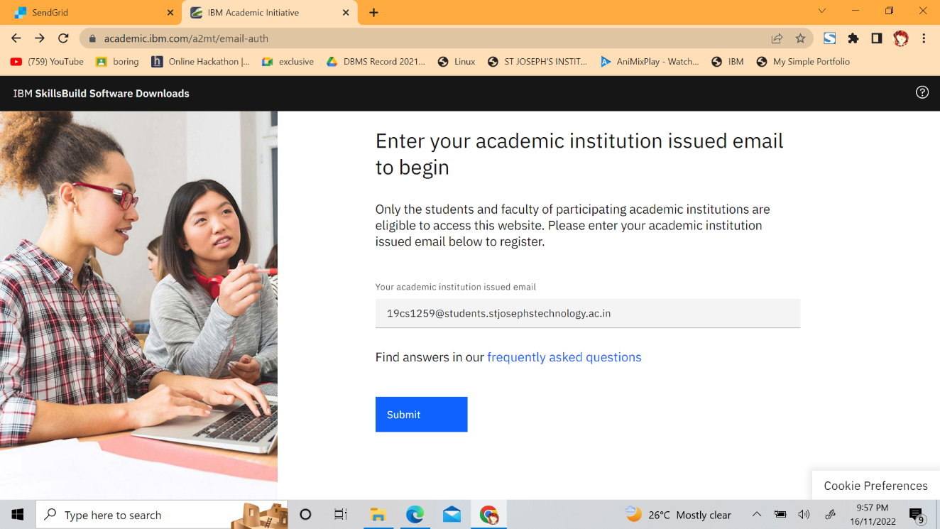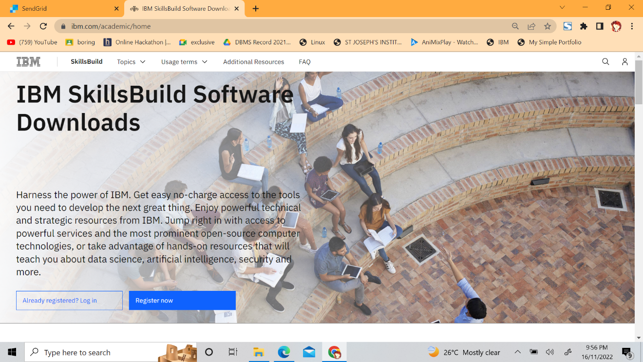Step 1. Navigate to ibm.com/academic and register with your smartinternz mail.

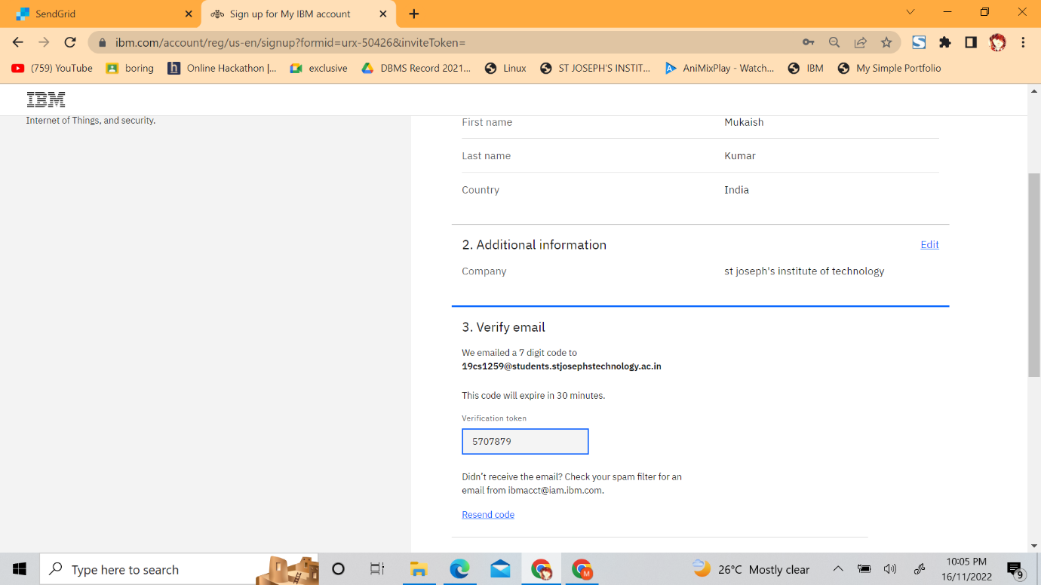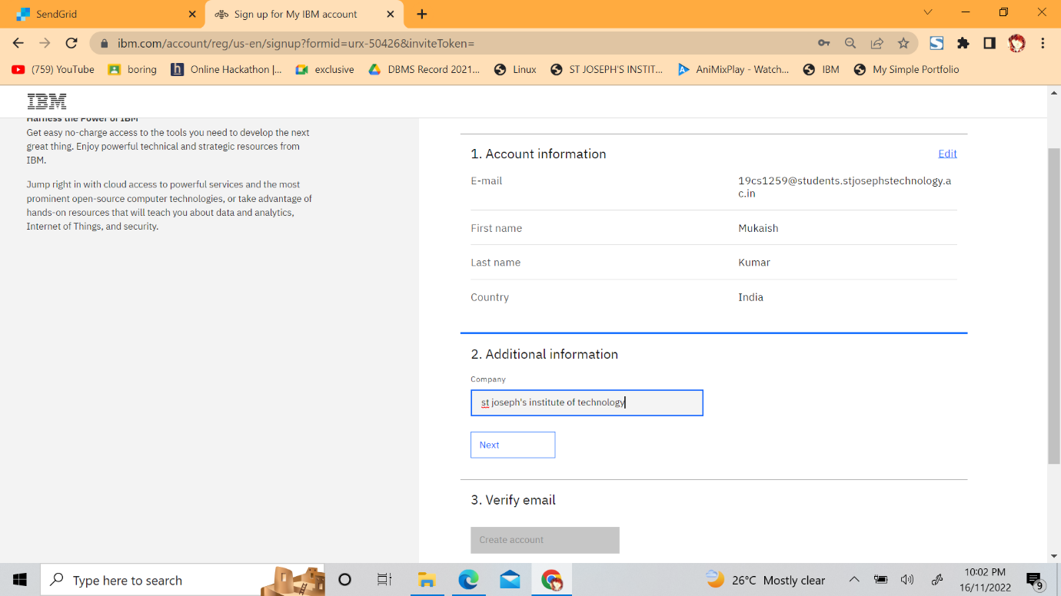Fill the necessary details and register.

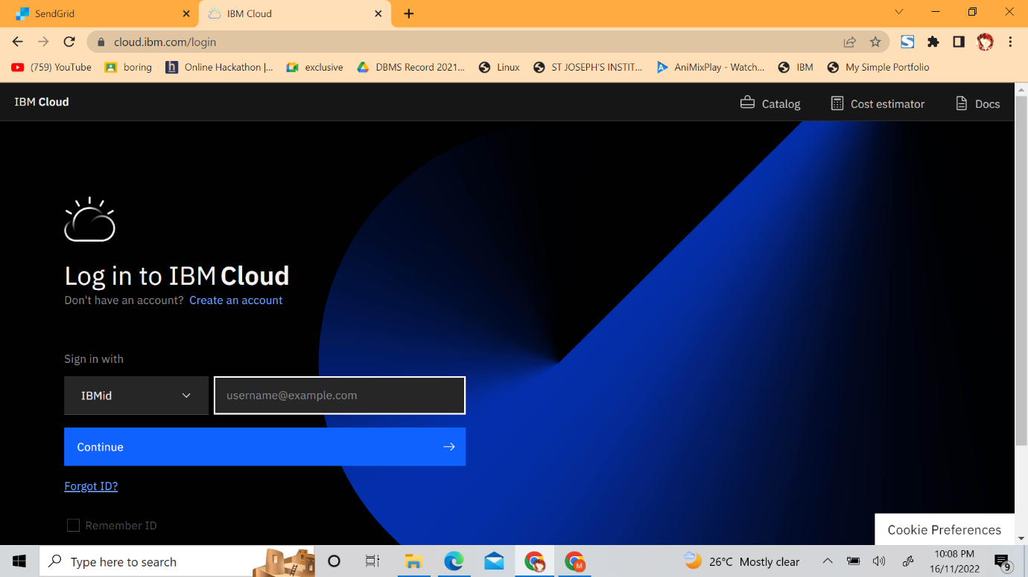**Step 2:** Now goto cloud.ibm.com and login with your registered mail id along with coupon code obtained from ibm.com/academic .

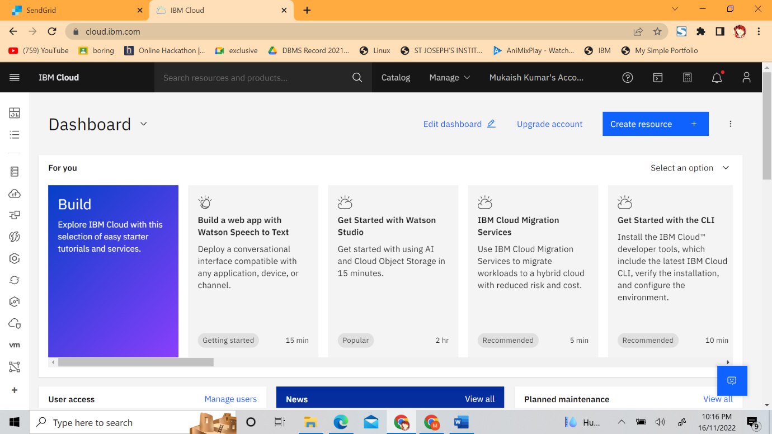

Output :

Cloud account created successfully.